Driving Reaction Time Under Distractive Conditions

Catherine Dumas
Dima Kassab
Anthony J. Leonardi
EPSY 887
Dependent Sample Assignment

13 February, 2011

Reaction times for breaking a car in a simulator, in milliseconds, were recorded for 20 subjects. In one case, reaction times were recorded while subjects were engaged in conversations with 3 other people in the car. A sudden appearance of a person in the road was interjected and subject breaking time was recorded. Reaction times of the same subjects were then measured with the addition of loud music in the car, where the subject and the other three people had to talk very loud to carry on a conversation. The research question was: Did the addition of the loud music have any effect on the reaction time?
There was a significant effect of adding the loud music (Figure 1). The dot plot shows a shift in the data toward the loud music data. The 95% CI shows this effect, and confirms the effect to be significant. The raw data is shown in Appendix A. The summary statistics are shown in Appendix B. This summary shows a mean difference of about 63.5, with a fairly large effect size (.956). This means the effect of adding noise over the conversation in the car has a large effect on reaction time required to stop the car. Thus, the t statistic is significant: t(19)=4.275, p<.001. The CI also shows significance as it does not pass through zero.
The additive plot is shown in Figure 2. The data was fit to the additive model. In order to show any interaction in the data, it was plotted using a quadratic function. This is shown in Figure 3. This Figure shows that there is an interaction between the two measurements as the graph loses its planarity.
Appendix C shows the graphic summary. This confirms that there is an interaction, although the interaction, albeit significant, appears to be small (-31.7 – 31.7).

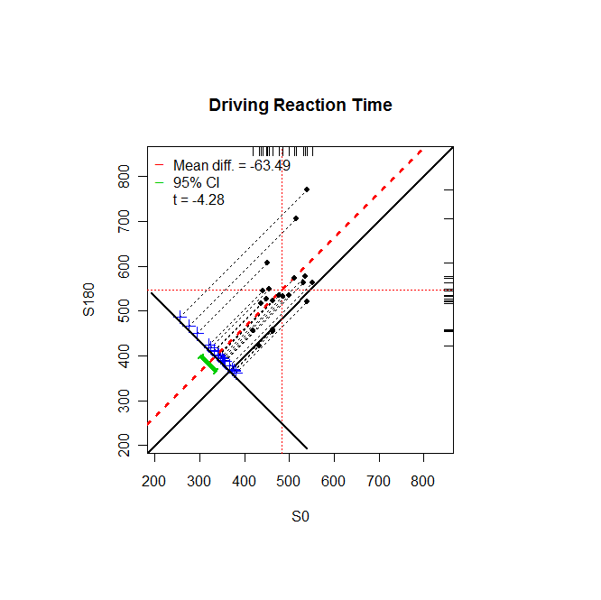
Figure 1. Plot of reaction time measured with conversation in the car
(x-axis) vs. measurements with loud music added (y-axis).
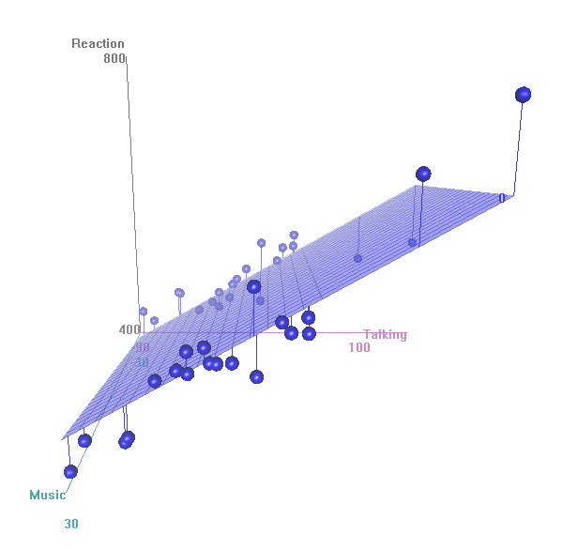
Figure 2. Additive 3D plot using the same data as in Figure 1.
Here, the model is plotted in three dimensions according to the
fit of the data to the additive model.

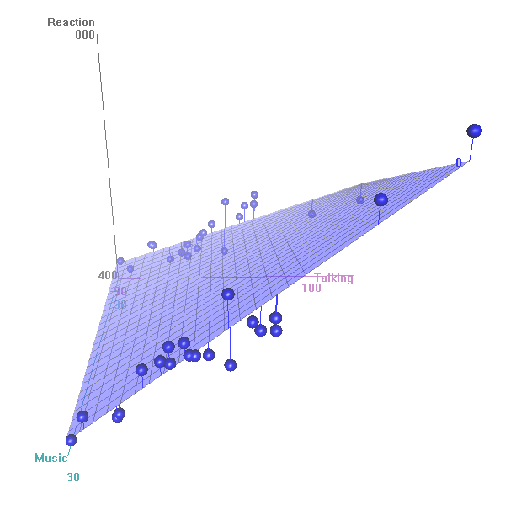
Figure 3. Reaction time data plotted with a quadratic function
to illustrate interaction between the paired measurements.

Appendix A: Raw Data
RT+3 People RT+Noise
455.6000061 | 549
419.0400085 | 455.4599915
448.7200012 | 526.3800049
539.8200073 | 770.7999878
463.7399902 | 454.2399902
433.6900024 | 422.8399963
512.289978 | 572.9899902
538.9899902 | 520.1900024
436.25 | 516.1400146
534.6699829 | 577.5200195
484.3599854 | 532.9400024
450.6099854 | 606.2000122
515.4799805 | 705.7399902
441.3800049 | 544.7999878
550.9099731 | 562.2000122
463.519989 | 523.2399902
476.5499878 | 533.6400146
499.7000122 | 533.7399902
532.0100098 | 562.8099976
462.3200073 | 458.6000061

Appendix B: Summary Statistics
Summary Stats
n 20.000
mean(x) 482.982
mean(y) 546.474
mean(D=x-y) -63.491
SD(D) 66.417
ES(D) -0.956
r(x,y) 0.574
r(x+y,d) -0.658
LL 95%CI -94.575
UL 95%CI -32.407
t(D-bar) -4.275
df.t 19.000
pval.t 0.000

Appendix C: Graphic Summary
[1] Reaction ~ Talking * Music
$Talking.effects
6 2 5 20 9 3 14 16 1 17 11
-86.50 -77.50 -55.70 -54.30 -38.50 -27.20 -21.60 -21.30 -12.40 -9.63 -6.08
18 12 8 7 19 10 15 13 4
1.99 13.70 14.90 27.90 32.70 41.40 41.80 95.90 141.00

$Music.effects
1 2
-31.7 31.7

$CellCounts.Reordered
Music
Talking 1 2
6 1 1
2 1 1
5 1 1
20 1 1
9 1 1
3 1 1
14 1 1
16 1 1
1 1 1
17 1 1
11 1 1
18 1 1
12 1 1
8 1 1
7 1 1
19 1 1
10 1 1
15 1 1
13 1 1
4 1 1

$CellMeans.Reordered
Music
Talking 1 2
6 434 423
2 419 455
5 464 454
20 462 459
9 436 516
3 449 526
14 441 545
16 464 523
1 456 549
17 477 534
11 484 533
18 500 534
12 451 606
8 539 520
7 512 573
19 532 563
10 535 578
15 551 562
13 515 706
4 540 771

$aov.summary
Df Sum Sq Mean Sq
Talking 19 115277 6067
Music 1 40311 40311
Talking:Music 19 41906 2206

